Project Development Phase
Model Performance Test

Date | 26 June 2025
Team ID | LTVIP2025TMID34134
Project Name | Pollen's Profiling: Automated Classification of Pollen Grains
Maximum Marks | 10 Marks

Model Performance Testing:
Project team shall fill the following information in model performance testing template.
S.No. | Parameter | Values | Screenshot
 | Metrics | Regression Model:  MAE - , MSE - , RMSE - , R2 score -  Classification Model:  Confusion Matrix - , Accuray Score- & Classification Report - | 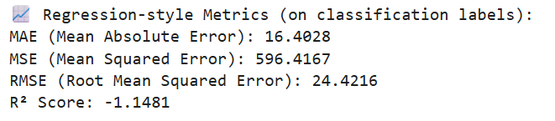  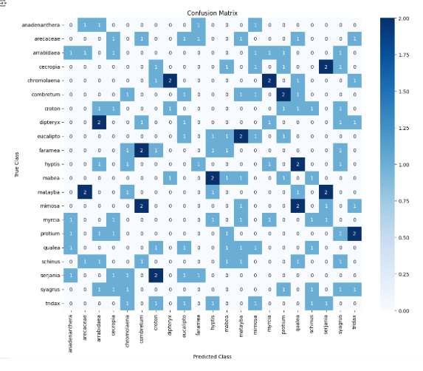
 | Tune the Model | Hyperparameter Tuning -  Validation Method -

